**Project Design Phase-I**

**Solution Architecture**

|  |  |
| --- | --- |
| Date | 06 November 2022 |
| Team ID | PNT2022TMID50773 |
| Project Name | Deep learning fundus image analysis for early detection of diabetic retinopathy |
| Maximum Marks | 4 Marks |

**Solution Architecture:**

Solution architecture shows the problems of the project and show the clear solution for it. It is a difficult process in the field of medical diagnosis. However it gives a strong solution to the problem. The main goals are:

1. Provide the basic structures of the given software and hardware requirements and to define the process of the project.
2. To define the planning and development phases of the system. To run a given application by the gives steps of the architecture.
3. Provide basic requirements needed to the given structure what could be essential.
4. Best solution to be categorize by the given objectives. To define the terms of the technical blocks.

**Solution Architecture Diagram:**

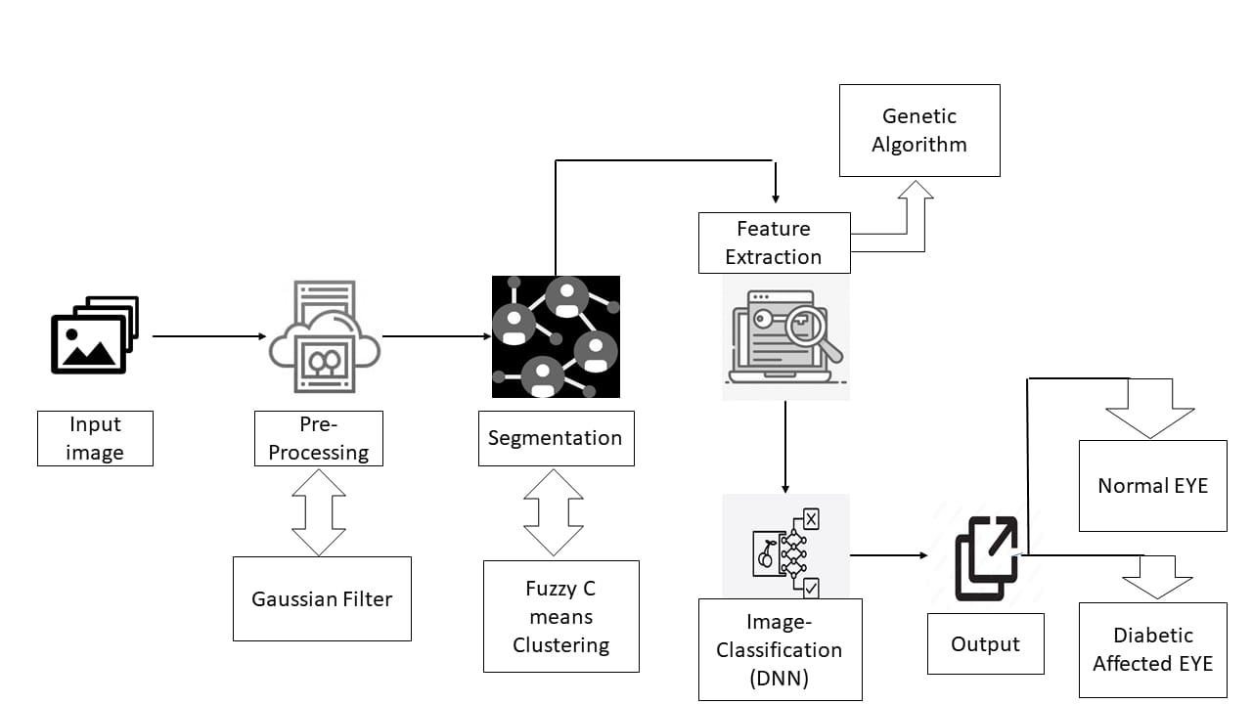

*Figure 1: Solution Architecture for the deep learning fundus image analysis*